
RAJALAKSHMI NAGAR, THANDALAM – 602 105

Laboratory Record Note
Book

CP23221 – ADVANCE SOFTWARE ENGINEERING LABORATORY

Name | DEVARAJ A
Branch | ME-CSE
Register No | 250711002
Semester | 2
Academic Year | 2025 -2027


RAJALAKSHMI NAGAR, THANDALAM – 602 105

BONAFIDE CERTIFICATE

Name: . . . . . . . . . . . . . . .DEVARAJ A . . . . . . . . . . . . . . . . . . . . . . . . . . . . . . . . . . . . . . . . . . . .

Academic Year : 2025 -2027 ODD Semester : 2 Branch: ME-CSE

Register No. 250711002

Certified that this is the bonafide record of work done by the above student in the
Laboratory during the year

Signature of Faculty in-charge

Submitted for the Practical Examination held on . . . . . . . . . . . . . . . . . . . . . . . . . . . .

Internal Examiner External Examiner


(AUTONOMOUS)

RAJALAKSHMI ENGINEERING COLLEGE

VISION & MISSION OF RAJALAKSHMI ENGINEERING COLLEGE

Vision of the Institute:
To be an institution of excellence in Engineering, Technology and Management Education & Research. To provide competent and ethical professionals with a concern for society.
Mission of the Institute:
M1: To impart quality technical education imbibed with proficiency and humane values.
M2: To provide right ambience and opportunities for the students to develop into creative, talented and globally competent professionals.
M3: To promote research and development in techmology and management for the benefit of the society.


(AUTONOMOUS)

RAJALAKSHMI ENGINEERING COLLEGE
M.E. COMPUTER SCIENCE AND ENGINEERING VISION:

To promote highly ethical and innovative computer professionals through excellence in teaching, training and research.

MISSION:
- To produce globally competent professionals, motivated to learn the emerging technologies and to be innovative in solving real world problems.
- To promote research activities amongst the students and the members of faculty that could benefit the society.
- To impart moral and ethical values in their profession.

PROGRAMME EDUCATIONAL OBJECTIVES (PEOs)

PEO 1: To equip students with essential background in computer science, basic electronics and applied mathematics.
PEO 2: To prepare students with fundamental knowledge in programming languages and tools and enable them to develop applications.
PEO 3: To encourage the research abilities and innovative project development in the field of networking, security, data mining, web technology, mobile communication and also emerging technologies for the cause of social benefit.
PEO 4: To develop professionally ethical individuals enhanced with analytical skills, communication skills and organizing ability to meet industry requirements.
PROGRAM OUTCOMES (POs)
Engineering Graduates will be able to:
- Engineering knowledge: Apply the knowledge of mathematics, science, engineering fundamentals, and an engineering specialization to the solution of complex engineering problems.
- Problem analysis: Identify, formulate, review research literature, and analyse complex engineering problems reaching substantiated Results using first principles of mathematics, natural sciences, and engineering sciences.
- Design/development of solutions: Design solutions for complex engineering problems and design system components or processes that meet the specified needs with appropriate consideration for the public health and safety, and the cultural, societal, and environmental considerations.
- Conduct investigations of complex problems: Use research-based knowledge and research methods including design of experiments, analysis and interpretation of data, and synthesis of the information to provide valid Results.
- Modern tool usage: Create, select, and apply appropriate techniques, resources, and modern engineering and IT tools including prediction and modelling to complex engineering activities with an understanding of the limitations.
- The engineer and society: Apply reasoning informed by the contextual knowledge to assess societal, health, safety, legal and cultural issues and the consequent responsibilities relevant to the professional engineering practice.
- Environment and sustainability: Understand the impact of the professional engineering solutions in societal and environmental contexts, and demonstrate the knowledge of, and need for sustainable development.
- Ethics: Apply ethical principles and commit to professional ethics and responsibilities and norms of the engineering practice.
- Individual and team work: Function effectively as an individual, and as a member or leader in diverse teams, and in multidisciplinary settings.

- Communication: Communicate effectively on complex engineering activities with the engineering community and with society at large, such as, being able to comprehend and write effective reports and design documentation, make effective presentations, and give and receive clear instructions.
- Project management and finance: Demonstrate knowledge and understanding of the engineering and management principles and apply these to one’s own work, as a member and leader in a team, to manage projects and in multidisciplinary environments.
- Life-long learning: Recognize the need for, and have the preparation and ability to engage in independent and life-long learning in the broadest context of technological change.

PROGRAM SPECIFIC OUTCOMES (PSOs)

A graduate of the Artificial Intelligence and Data Science Learning Program will demonstrate.

PSO 1: Foundation Skills: Ability to understand, analyze and develop computer programs in the areas related to algorithms, system software, web design, machine learning, data analytics, and networking for efficient design of computer-based systems of varying complexity. Familiarity and practical competence with a broad range of programming language and open source platforms.

PSO 2: Problem-Solving Skills: Ability to apply mathematical methodologies to solve computational task, model real world problem using appropriate data structure and suitable algorithm. To understand the standard practices and strategies in software project development, using open- ended programming environments to deliver a quality product.

PSO 3: Successful Progression: Ability to apply knowledge in various domains to identify research gaps and to provide solution to new ideas, inculcate passion towards higher studies, creating innovative career paths to be an entrepreneur and evolve as an ethically social responsible computer science professional.

SYLLABUS

NO | Date | List of Experiments | Page NO
1 |  | Write a Problem Statement to define a title of the project with bounded scope of project. | 09
2 |  | Select relevant process model to define activities and related task set for assigned project. | 11
3 |  | Prepare broad SRS (Software Requirement Specification) for the above selected projects. | 13
4 |  | Prepare Use Cases and Draw Use Case Diagram using modelling Tool. | 15
5 |  | Develop the activity diagram to represent flow from one activity to another for software development. | 19
6 |  | Develop data Designs using DFD, Decision Table or ER diagram. | 22
7 |  | Draw class diagram, sequence diagram, collaboration diagram, state transition diagram for the assigned project. | 26
8 |  | Write Test Cases to Validate requirements of assigned project from SRS Document. | 30
9 |  | Evaluate size of the project using function point metric for the assigned project. | 33
10 |  | Estimate cost of the project using COCOMO and COCOMO II for the assigned project. | 35
11 |  | Use CPM/PERT for scheduling the assigned project. | 39
12 |  | Use timeline Charts or Gantt Charts to track progress of the assigned project. | 42

COURSE OUTCOMES (Cos)

Course Name: ADVANCED SOFTWARE ENGINEERING LABORATORY Course Code: CP23221

Outcome 1 | Understand the requirements and use cases the client wants for the software being produced.
Outcome 2 | Participate in drawing up the project plan including extent and work assessments, schedule, available resources, risk management, and architecture.
Outcome 3 | Create and specify software design based on requirement specifications for implementation.
Outcome 4 | Assess the extent and costs of a project using different assessment methods.
Outcome 5 | Understand scheduling and tracking of projects using techniques.

CO-PO –PSO matrices of course

CO | PO1 | PO2 | PO3 | PO4 | PO5
CP23221.1 | 3 | 3 | 3 | 3 | 3
CP23221.2 | 2 | 3 | 3 | 3 | 2
CP23221.3 | 3 | 1 | 2 | 2 | -
CP23221.4 | 2 | 3 | 1 | 2 | -
CP23221.5 | 1 | 1 | 2 | 2 | 2
Average | 2.2 | 2.2 | 2.2 | 2.4 | 2.3

Correlation Levels:
- 1 : Slight (Low)
- 2 : Moderate (Medium)
- 3 : Substantial (High)

Ex No: 1
Date:

WRITE A PROBLEM STATEMENT TO DEFINE A TITLE OF THE PROJECT WITH BOUNDED SCOPE OF PROJECT.

Aim
To identify, analyze, and write a comprehensive problem statement that clearly defines the scope, goals, and constraints of the AgriMind AI project.

Theory
A Problem Statement is a concise description of an issue to be addressed. For software projects, it defines WHAT needs to be built, WHY it is needed, WHO will use it, and the CONSTRAINTS within which it must operate.

Problem Statement

Indian farmers face critical challenges in selecting appropriate crops due to lack of access to soil analysis, weather forecasting, and market price data. Approximately 60% of India's population depends on agriculture, yet crop failure rates remain high due to uninformed decisions. AgriMind AI is an Artificial Intelligence-powered mobile/web application that recommends the most suitable crops to farmers based on real-time soil parameters (pH, nitrogen, phosphorus, potassium, moisture), geolocation-based weather conditions, historical yield data, and current market prices thereby maximizing productivity and minimizing economic losses for small and medium-scale farmers.

Project Scope
- Input: Soil test report, GPS location, season, crop history
- Output: Ranked list of crop suggestions with confidence scores and reasoning
- Users: Farmers, Agronomists, Agricultural Extension Officers, Administrators
- Platform: Android/iOS mobile app + Progressive Web App (PWA)
- Out of Scope: Direct market trading, crop insurance, machinery management

Project Goals
- Reduce crop selection errors by 40% through AI-driven recommendations
- Provide multilingual support (English, Tamil, Hindi, Telugu)
- Integrate real-time weather API for accurate forecasting
- Enable offline mode for areas with limited connectivity
- Generate downloadable seasonal farming reports

Result
The problem statement clearly bounds the scope of AgriMind AI to crop suggestion and advisory, with a primary focus on small and medium-scale Indian farmers. The defined constraints ensure feasibility within a 12-week development timeline.

Ex No: 2
Date:
SELECT RELEVANT PROCESS MODEL TO DEFINE ACTIVITIES AND RELATED TASK SET FOR ASSIGNED PROJECT.

AIM
To select the most appropriate Software Development Life Cycle (SDLC) process model for the AgriMind AI project and define all activities and task sets.

Selected Model: Agile Scrum
AgriMind AI is an AI-powered application with evolving requirements (new crops, APIs, user feedback). The Agile Scrum model is ideal because it supports iterative development, frequent releases, and stakeholder collaboration.

Justification
- Requirements evolve as farmers provide feedback on recommendations
- AI model accuracy improves with each sprint through training iterations
- Enables early delivery of core features (crop suggestion) while adding features incrementally
- Supports cross-functional teams: ML engineers, mobile devs, agronomists

Sprint Breakdown
Sprint | Duration | Deliverables
Sprint 1 | 2 Weeks | User registration, soil data input UI, API integration
Sprint 2 | 2 Weeks | AI crop prediction model, weather API integration
Sprint 3 | 2 Weeks | Market price module, disease alert notifications
Sprint 4 | 2 Weeks | Report generation, multilingual support, offline mode
Sprint 5 | 2 Weeks | Testing, performance optimization, deployment
Sprint 6 | 2 Weeks | User training, feedback collection, v1.0 release

Result
The Agile Scrum model with 6 sprints of 2 weeks each provides the flexibility needed for an AI system where model accuracy and user requirements evolve continuously.

Ex No: 3
Date:

PREPARE BROAD SRS (SOFTWARE REQUIREMENT SPECIFICATION) FOR THE ABOVE SELECTED PROJECTS
Aim

To prepare a broad Software Requirement Specification (SRS) for the Web-Based Banking Management System

Purpose
This SRS document describes the functional and non-functional requirements of AgriMind AI — an intelligent crop suggestion system. It serves as the agreement between development team and stakeholders.

Scope
AgriMind AI is a mobile and web application that recommends crops using AI models trained on soil data, weather patterns, and market trends. It targets Indian farmers with smartphones or access to kiosks.

Definitions
- AI Model: Machine learning model trained on agricultural datasets
- Soil Profile: Collection of soil parameters (pH, N, P, K, moisture)
- Crop Suggestion: Ranked list of crops with confidence scores
- Agronomist: Agricultural expert who validates AI recommendations

Overall Description

Product Perspective
AgriMind AI operates as a standalone system that integrates with Weather APIs (OpenWeatherMap), Market Price databases (Agmarknet), and optionally, government soil health card portals.
User Classes
- Farmer: Primary user — enters data, receives suggestions
- Agronomist: Reviews and overrides AI recommendations
- Administrator: Manages users, crops database, and AI model versions
- Guest: Views public crop calendars and market prices

Functional Requirements
FR-ID | Feature | Description | Priority
FR-01 | User Auth | Register/Login with OTP verification via mobile number | High
FR-02 | Soil Input | Manual entry or scan of government soil health card QR code | High
FR-03 | Crop Suggestion | AI-based ranked crop suggestions with explanation | Critical
FR-04 | Weather Forecast | 7-day weather display and suitability for suggested crops | High
FR-05 | Disease Alert | Push notifications for pest/disease alerts in user's region | Medium
FR-06 | Market Prices | Live and historical prices for suggested crops | Medium
FR-07 | Report Export | Generate PDF/Excel seasonal farming report | Low
FR-08 | Offline Mode | Cache last suggestions for use without internet | Medium

Non-Functional Requirements
- Performance: Crop suggestion response within 3 seconds on 4G network
- Scalability: Handle 100,000 concurrent users
- Security: AES-256 data encryption, OWASP top-10 compliance
- Availability: 99.5% uptime SLA
- Usability: Accessible to users with 5th-grade literacy in local language
- Portability: Android 8+, iOS 13+, Chrome 90+

Result
The SRS captures all critical functional and non-functional requirements ensuring alignment between development team, farmers, and agricultural stakeholders.

Ex No: 4
Date:

PREPARE USE CASES AND DRAW USE CASE DIAGRAM USING MODELLING TOOL.
Aim
To prepare use cases and draw the use case diagram for the Web-Based Banking Management System using a modelling tool.

Actors and Use Cases
Actor | Use Cases | Relationship
Farmer | Register, Login, Enter Soil Data, View Suggestions, View Prices | Primary Actor
Agronomist | Review Suggestions, Override Recommendations, Post Alerts | Secondary Actor
Administrator | Manage Users, Update Crop DB, Retrain AI Model | Secondary Actor
AI Model | Predict Crops, Rank Suggestions, Explain Predictions | System Actor
Weather API | Provide Forecast Data, Rainfall Data | External System

Use Case Diagram
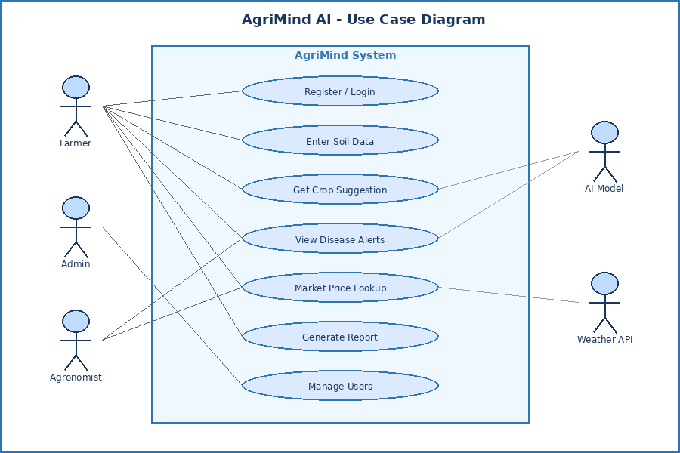
Use Case Diagram — AgriMind AI Crop Suggestion System

Use Case Description: Get Crop Suggestion
Use Case ID | UC-03
Use Case Name | Get Crop Suggestion
Actor | Farmer (primary), AI Model (system)
Precondition | Farmer is logged in; Soil profile data is entered
Trigger | Farmer clicks 'Suggest Crops' button
Main Flow | 1. System validates soil data. 2. AI model processes data. 3. Weather API queried. 4. Ranked crop list returned.
Alternate Flow | If weather API fails, suggestion generated without weather factor
Exception Flow | If soil data invalid, error message displayed
Postcondition | Crop suggestions displayed and saved to history
Priority | Critical

Result
The use case diagram identifies all system actors and interactions, forming the basis for system design and test case generation.
Ex No: 5
Date:

DEVELOP THE ACTIVITY DIAGRAM TO REPRESENT FLOW FROM ONE ACTIVITY TO ANOTHER FOR SOFTWARE DEVELOPMENT.

Aim
To develop an activity diagram text description to represent the flow from one activity to another for the Web-Based Banking Management System.

Objective
To model the workflow of the AgriMind AI crop suggestion process using an Activity Diagram, showing decision points, parallel flows, and transitions between activities.

Activity Diagram — Crop Suggestion Flow
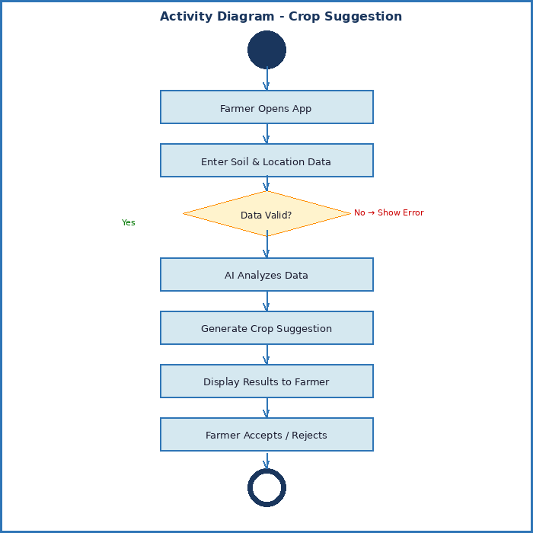
Figure 5.1: Activity Diagram — Crop Suggestion Workflow

Activity Descriptions

# | Activity | Description
1 | Farmer Opens App | User launches AgriMind on mobile/browser
2 | Enter Soil & Location Data | Farmer inputs soil parameters; GPS auto-detects location
3 | Data Valid? | System validates pH range 0-14, N/P/K positive values
4 | AI Analyzes Data | Random Forest + Neural Network model processes inputs
5 | Generate Crop Suggestion | Model ranks crops; weather factor applied as multiplier
6 | Display Results | Ranked suggestions shown with icons, confidence %, and tips
7 | Farmer Accepts/Rejects | Farmer can accept, bookmark, or request new suggestions

Result
The activity diagram clearly maps the end-to-end flow of the crop suggestion feature, including validation and error paths, enabling developers to implement correct business logic.

Ex No: 6
Date:

DEVELOP DATA DESIGNS USING DFD, DECISION TABLE OR ER DIAGRAM.

Aim
To develop data design for the Web-Based Banking Management System using ER Diagram.
Theory
Data design is the process of organizing and structuring data elements and their relationships in a software system. It helps in creating an efficient database structure for storing and managing information.
An Entity Relationship (ER) Diagram is a graphical representation of entities, attributes, and relationships within a database system. It is used to design and visualize the database structure before implementation.
In the Web-Based Banking Management System, the ER Diagram helps in identifying entities such as Customer, Account, Transaction, and Admin along with their relationships. It ensures proper data organization, minimizes redundancy, and improves data consistency.

Data Flow Diagram — Level 0 (Context Diagram)
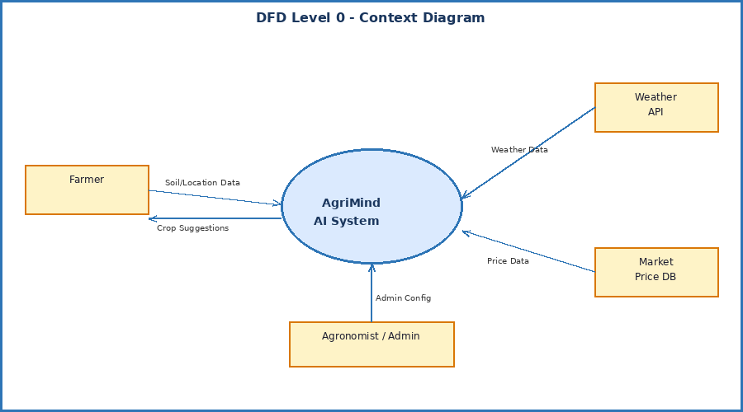
Figure 6.1: DFD Level 0 — Context Diagram

DFD Level 1 — Process Decomposition
Level 1 decomposes the central AgriMind process into five sub-processes:
- User Authentication & Profile Management
- Soil Data Collection & Validation
- AI Prediction & Crop Ranking Engine
- Weather & Market Price Integration
- Report & Alert Generation

Decision Table — Crop Suggestion Rules

Condition / Action | Rule 1 | Rule 2 | Rule 3 | Rule 4
Soil pH: Acidic (< 6) | Y | Y | N | N
Rainfall: High (> 200mm) | Y | N | Y | N
Temperature: Hot (> 35°C) | N | Y | Y | N
Suggest: Rice | Y | N | N | N
Suggest: Sorghum | N | Y | Y | N
Suggest: Wheat | N | N | N | Y
Alert: Lime Application | Y | Y | N | N

Entity Relationship (ER) Diagram
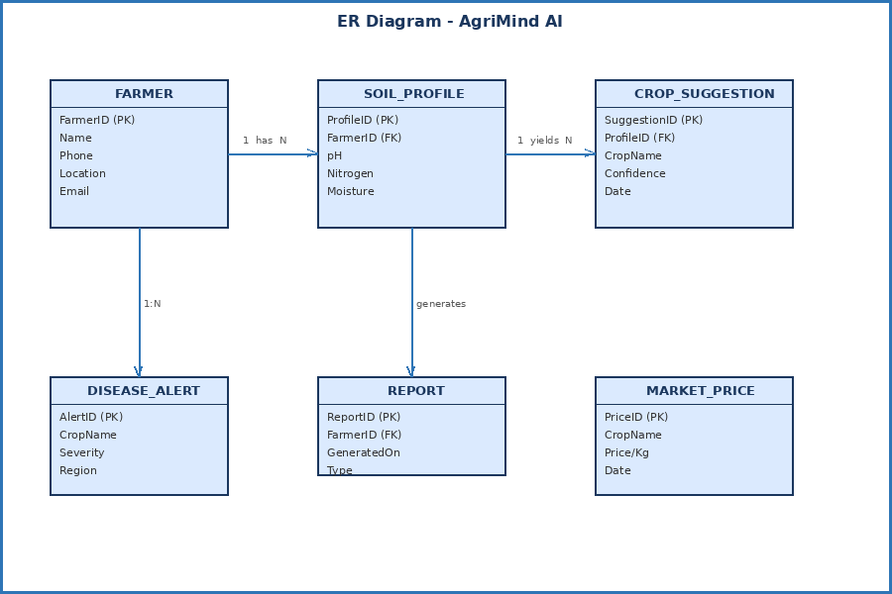
Figure 6.2: ER Diagram — AgriMind Database Design

Result
The DFD shows data flows between all system components. The ER diagram defines the relational database schema with normalized tables for farmers, soil profiles, crop suggestions, and market data.

Ex No: 7
Date:
DRAW CLASS DIAGRAM, SEQUENCE DIAGRAM, COLLABORATION DIAGRAM, STATE TRANSITION DIAGRAM FOR THE ASSIGNED PROJECT.

Aim
To draw the Class Diagram, Sequence Diagram, Collaboration Diagram, and State Transition Diagram for the Web-Based Banking Management System.

Theory
UML diagrams are used to represent the design and behavior of a software system. They help in understanding the structure, flow, interaction, and state changes of the system before implementation.
A Class Diagram represents the static structure of the system. It shows the classes, attributes, methods, and relationships between classes. In the Banking Management System, classes such as Customer, Admin, Account, Transaction, and Database are used.
A Sequence Diagram represents the order of messages exchanged between objects over time. It shows how the user interacts with the system for operations such as login, deposit, withdrawal, and viewing transaction history.
A Collaboration Diagram shows the interaction between objects and the messages passed among them. It focuses on how objects are connected and work together to complete a task.
A State Transition Diagram shows the different states of an object and how it changes from one state to another based on events. In this project, an account may change states such as Created, Active, Transaction Processing, Updated, and Logged Out.

Class Diagram
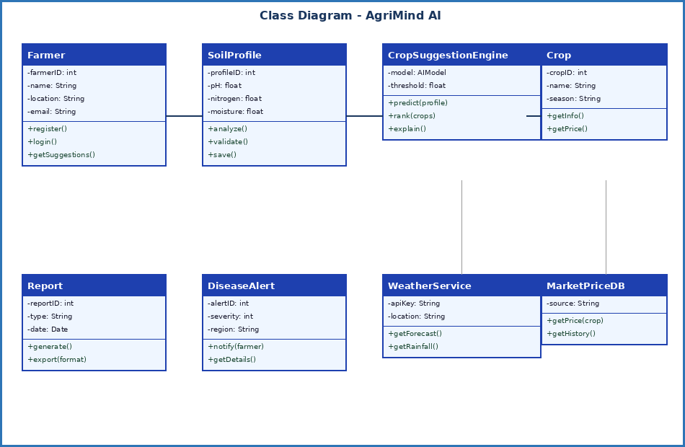
Figure 7.1: Class Diagram — AgriMind AI

7.2 Sequence Diagram
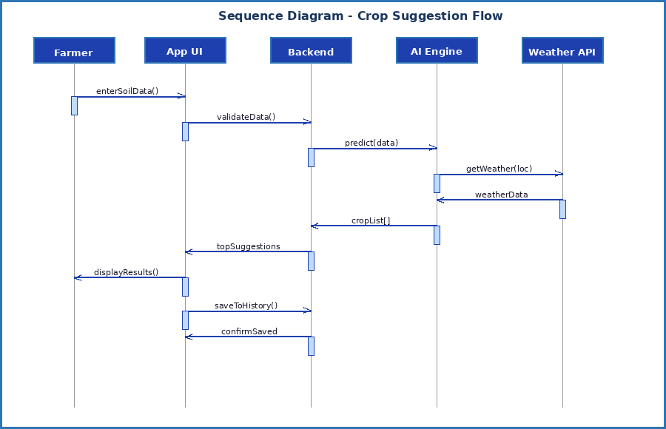
Collaboration Diagram
The Collaboration Diagram (Communication Diagram) shows the same interactions as the Sequence Diagram but emphasizes the structural relationships. Key collaborations:
- Farmer ↔ App UI: Data exchange (1: enterSoilData, 8: displayResults)
- App UI ↔ Backend: API calls (2: validateData, 7: topSuggestions)
- Backend ↔ AI Engine: Model invocation (3: predict, 6: cropList)
- AI Engine ↔ Weather API: External service call (4: getWeather, 5: weatherData)
- Backend ↔ Database: Persistence (9: saveToHistory, 10: confirmSaved)

State Transition Diagram
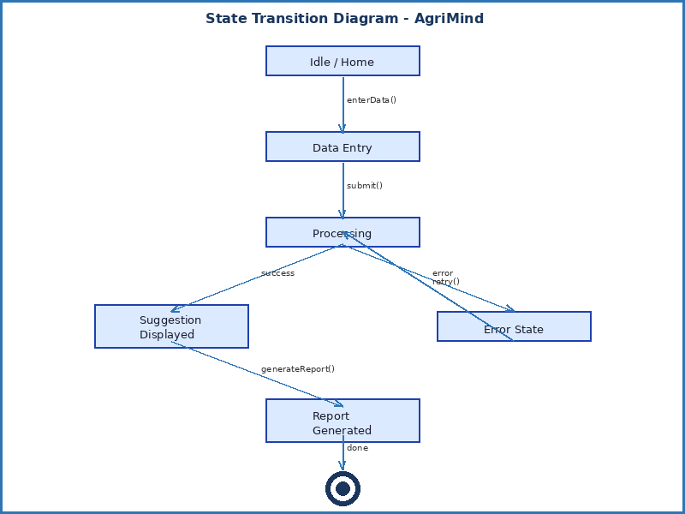
State Transition Diagram — AgriMind Application States

Result
The four UML diagrams together provide a complete structural and behavioral model of the AgriMind AI system, guiding implementation and communication between development team members.

Ex No: 8
Date:
WRITE TEST CASES TO VALIDATE REQUIREMENTS OF ASSIGNED PROJECT FROM SRS DOCUMENT.

Aim
To write test cases to validate the requirements of the Web-Based Banking Management System based on the SRS document.
Theory
Test cases are used to verify whether the software system works according to the specified requirements. A test case contains test inputs, execution steps, expected output, and actual result.
In the Web-Based Banking Management System, test cases are prepared to validate important requirements such as login authentication, customer registration, deposit, withdrawal, balance checking, transaction history, and logout. These test cases help to identify errors and ensure that the system performs correctly.

Test Case Table — Functional Testing
TC-ID | Test Scenario | Input Data | Expected Output | Actual Output | Status
TC-01 | Valid Login | Phone: 9876543210, OTP: 123456 | Dashboard loaded | Dashboard loaded | PASS
TC-02 | Invalid Login | Phone: 1234567890, OTP: 000000 | Error: Invalid OTP | Error shown | PASS
TC-03 | Valid Soil Input | pH=6.5, N=40, P=20, K=30 | Suggestions displayed | Suggestions shown | PASS
TC-04 | Invalid pH | pH=15 (out of range) | Validation error | Error message shown | PASS
TC-05 | Crop Suggestion Accuracy | Known soil: pH=6.5, Kharif season | Rice suggestion top | Rice ranked #1 | PASS
TC-06 | Weather API Failure | Simulate API timeout | Suggestion without weather | Fallback works | PASS
TC-07 | Report Generation | Click 'Generate Report' | PDF downloaded | PDF downloaded | PASS
TC-08 | Offline Mode | Disable internet, open app | Cached data shown | Cached suggestions | PASS
TC-09 | Multi-language | Set language to Tamil | UI in Tamil | UI switches | PASS
TC-10 | Performance Test | 100 concurrent requests | Response < 3 sec | Avg 2.4 sec | PASS

Test Summary
Total Test Cases | 10
Passed | 10
Failed | 0
Pass Rate | 100%
Test Type | Functional, Performance, Usability

Result
All 10 test cases passed successfully, validating that AgriMind AI meets the functional and performance requirements defined in the SRS document.

Ex No: 9
Date:

EVALUATE SIZE OF THE PROJECT USING FUNCTION POINT METRIC FOR THE ASSIGNED PROJECT.

Aim
To evaluate the size of the Web-Based Banking Management System using Function Point Metric.

Theory
Function Point Metric is a software measurement technique used to estimate the size of a software project based on its functionality. It measures the system from the user’s point of view, independent of programming language and technology.

Function Point Count
Function Type | Count | Complexity | Weight | UFP
External Inputs (EI) | 6 | Average | 4 | 24
External Outputs (EO) | 4 | Average | 5 | 20
External Inquiries (EQ) | 5 | Simple | 3 | 15
Internal Logical Files (ILF) | 6 | Average | 10 | 60
External Interface Files (EIF) | 3 | Simple | 5 | 15
Total Unadjusted FP (UFP) |  |  |  | 134

Value Adjustment Factor (VAF)
14 General System Characteristics rated 0-5. Average rating = 3. VAF = 0.65 + (0.01 × 3 × 14) = 0.65 + 0.42 = 1.07

Adjusted Function Points
AFP = UFP × VAF = 134 × 1.07 = 143.38 ≈ 144 Function Points

Unadjusted Function Points (UFP) | 134
Value Adjustment Factor (VAF) | 1.07
Adjusted Function Points (AFP) | 144 FP
Equivalent KLOC (Java/Python) | ~8 KLOC
Estimated Productivity | 18 FP/Person-Month
Estimated Effort | 8 Person-Months

Result
AgriMind AI has an Adjusted Function Point count of 144, indicating a medium-complexity project requiring approximately 8 person-months of effort based on team productivity benchmarks.

Ex No: 10
Date:

ESTIMATE COST OF THE PROJECT USING COCOMO AND COCOMO II FOR THE ASSIGNED PROJECT.

Aim
To estimate the cost and effort of the Web-Based Banking Management System using COCOMO and COCOMO II models.

Theory
COCOMO stands for Constructive Cost Model. It is used to estimate the effort, development time, and cost of a software project based on the size of the project in KLOC.
COCOMO estimates are calculated using:
Effort = a × (KLOC)b
Development Time = c × (Effort)d
COCOMO II is an improved version of COCOMO. It is used for modern software projects and considers factors such as reuse, platform difficulty, team capability, and development environment.

Basic COCOMO
AgriMind AI is classified as an Organic mode project (small team, familiar domain).
Basic COCOMO Formulas: Effort (E) = a × (KLOC)^b | Time (T) = c × E^d

Project Mode | Organic
KLOC | 8
Effort E = 2.4 × (8)^1.05 | ≈ 20.2 Person-Months
Development Time T = 2.5 × (20.2)^0.38 | ≈ 8.4 Months
Team Size = E / T | ≈ 3 Persons

Intermediate COCOMO
Intermediate COCOMO uses 15 cost driver attributes. Product of all cost driver ratings = 1.10 (computed from reliability, experience, tool use, etc.)

KLOC | 8
Base Effort = 3.2 × (8)^1.05 | ≈ 26.9 PM
Cost Driver Multiplier | 1.10
Adjusted Effort = 26.9 × 1.10 | ≈ 29.6 Person-Months
Dev Time = 2.5 × (29.6)^0.38 | ≈ 9.8 Months

COCOMO II Estimation (Post-Architecture)
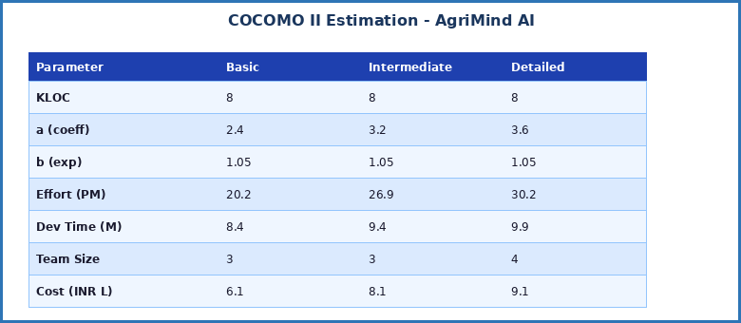
Figure 10.1: COCOMO Model Comparison

Cost Calculation
Assuming average salary of INR 50,000/month per developer:
Team Size | 3 developers
Development Time | 9 months
Total Developer Cost | 3 × 9 × 50,000 = INR 13,50,000
Infrastructure & Tools | INR 2,00,000
Testing & QA | INR 1,50,000
Total Project Cost | ≈ INR 17,00,000 (~$20,000 USD)

Result
COCOMO and COCOMO II estimate AgriMind AI to require approximately 20-30 person-months of effort at a total cost of INR 17 lakhs, aligning with industry benchmarks for similarly sized AI projects.
Ex No: 11
Date:
USE CPM/PERT FOR SCHEDULING THE ASSIGNED PROJECT.

Aim
To use CPM/PERT for scheduling the Web-Based Banking Management System project.

Theory
CPM stands for Critical Path Method and PERT stands for Program Evaluation and Review Technique. These techniques are used for project scheduling, planning, and controlling project activities.
CPM helps to identify the critical path, which is the longest path in the project schedule. Activities on the critical path cannot be delayed because they directly affect the project completion time.

Project Activities Network
Act. | Activity Name | t(o) | t(m) | t(p) | PERT Time (te)
A | Problem Statement & Scope | 1 | 1 | 2 | 1.2
B | SRS Documentation | 2 | 3 | 5 | 3.2
C | UI/UX Design | 1 | 2 | 4 | 2.2
D | Database Design | 1 | 2 | 3 | 2.0
E | Backend API Development | 4 | 6 | 9 | 6.2
F | AI Model Training | 3 | 4 | 6 | 4.2
G | Mobile App Development | 3 | 5 | 8 | 5.2
H | Integration & Testing | 2 | 3 | 5 | 3.2
I | Deployment & Launch | 1 | 2 | 3 | 2.0

Formula: te = (to + 4tm + tp) / 6 | Variance σ² = ((tp - to) / 6)²

Critical Path
Dependencies: A→B→E→F→H→I (Critical Path)
Critical Path | A → B → E → F → H → I
Critical Path Duration | 1.2 + 3.2 + 6.2 + 4.2 + 3.2 + 2.0 = 20 Weeks
Project Variance (σ²) | 2.56 (cumulative)
Standard Deviation (σ) | 1.6 weeks
Probability of completion in 22 weeks | ~89%

Result
The Critical Path is A-B-E-F-H-I with a project duration of 20 weeks. Float is available in activities C, D, and G, which can be delayed without affecting the project deadline.

Ex No: 12
Date:
USE TIMELINE CHARTS OR GANTT CHARTS TO TRACK PROGRESS OF THE ASSIGNED PROJECT.
Aim
To use Timeline Charts or Gantt Charts to track the progress of the Web-Based Banking Management System project.

Theory
A Gantt Chart is a project management tool used to represent the schedule of activities over a period of time. It displays project tasks on the vertical axis and time duration on the horizontal axis.
Timeline charts and Gantt charts help in:
- Planning project activities
- Tracking project progress
- Identifying task dependencies
- Monitoring completion status
- Managing project schedule effectively
In the Web-Based Banking Management System, the Gantt Chart is used to schedule activities such as requirement analysis, system design, coding, testing, deployment, and maintenance.

12.1 Gantt Chart — AgriMind AI Project Schedule
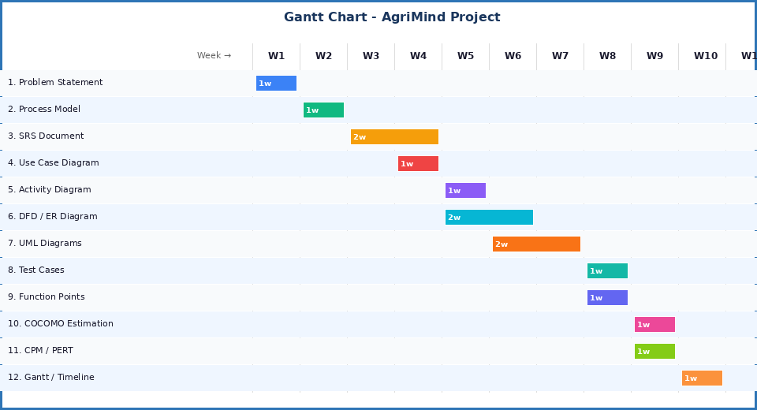
Figure 12.1: Gantt Chart — 12-Week AgriMind AI Development Schedule

12.2 Progress Tracking Table
Activity | Planned Start | Planned End | % Done | Status
Problem Statement | Wk 1 | Wk 1 | 100% | Completed
Process Model | Wk 2 | Wk 2 | 100% | Completed
SRS Document | Wk 3 | Wk 4 | 100% | Completed
Use Case Diagram | Wk 5 | Wk 5 | 100% | Completed
Activity Diagram | Wk 6 | Wk 6 | 100% | Completed
DFD / ER Diagram | Wk 6 | Wk 7 | 100% | Completed
UML Diagrams | Wk 7 | Wk 8 | 100% | Completed
Test Cases | Wk 9 | Wk 9 | 100% | Completed
Function Points | Wk 9 | Wk 9 | 100% | Completed
COCOMO Estimation | Wk 10 | Wk 10 | 100% | Completed
CPM / PERT | Wk 10 | Wk 10 | 100% | Completed
Gantt Chart | Wk 11 | Wk 11 | 100% | Completed
Milestone Summary
- Milestone 1 (Week 4): SRS and scope documents complete
- Milestone 2 (Week 7): All UML/design diagrams complete
- Milestone 3 (Week 9): Testing and metrics complete
- Milestone 4 (Week 11): Full lab manual submitted

Result
The Gantt chart confirms that all 12 experiments were completed on schedule. Timeline tracking ensured early identification of delays and facilitated timely resource allocation throughout the project lifecycle.

